
To: WV STARS Professional Development (PD) Providers
From: WV STARS
Date: August 3, 2023
Re: Updates to “Module’s Percentage Toward Course Final Score and Completion” settings of a Course

Hello WV STARS PD Providers!
If you have been creating new courses, you may have noticed a change with the section called “Module’s Percentage Toward Course Final Score and Completion” within a module (see below):

This setting dictates how much weight (in percent) a module will have on the overall score for this course. If you are just using a singular Scheduled Event module in your course, it will be set to 100 for that module.
If you have multiple scheduled event modules or are using other types of modules (e.g., Assessment, Assignment, Document, etc.) along with a scheduled event module, you will need to ensure that the percentages you list does not exceed the total 100% for the course.
For example, if you are using one scheduled event module and an assessment (exam) module for your course, you could set both the scheduled event percentage and assessment module percentage to 50% or set the assessment module to 75% and the scheduled event module to 25%. Ultimately how the percentage is divided is up to the course creator, just make sure total across all modules equals (but does not exceed!) 100%.
If you accidentally exceed 100%, you’ll be greeted with the below message once you try to submit the course for publishing approval:

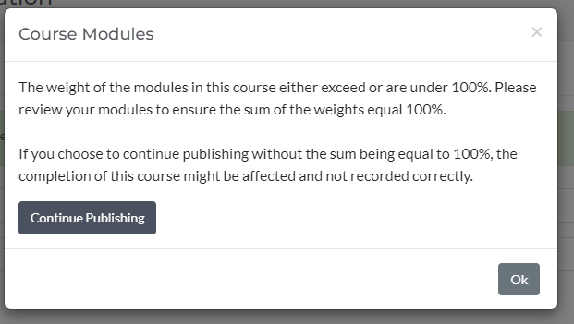
If you see this message, simply check your modules, and see where the percentage needs to be adjusted. Please note that you cannot move forward with submitting the course for publishing approval until the percentage has been corrected. You can tell this is the case because the “Next Visibility and Setting” option will not show up:

Once you correct the percentages, you will be able to move forward.

Please contact me with any questions regarding these changes.

Thank you,
Stacy Price, MS  WV STARS Training Specialist  WV State Training and Registry System (WV STARS)  www.wvstars.org  www.facebook.com/wvstars | 611 Seventh Avenue, Suite 322  Huntington, WV 25701  T: 304-522-7827 x3471  F: 304-529-2535  sprice@rvcds.org

Administered by WV Early Childhood Training Connections and Resources, a program of River Valley Child Development Services “Serving Children and Families since 1971”.

